- The Monetary Policy Committee voted to cut Bank Rate by 25bps to 4% at its meeting this week. But the vote was unexpectedly tight, and the MPC's messaging was much more hawkish than anticipated. On balance, we still expect another 25bps cut in November, but our call is made with much less confidence. Whether inflation continues to surprise to the upside will likely prove key.
- Though the MPC's review of quantitative tightening suggested there was little evidence that it has had a major impact on market functioning and gilt yields, the BoE conceded that the risks could be higher in future. We expect the MPC to reduce the pace of QT at next month's meeting.
The Bank of England's monetary policy decision was the week's main event. Coming into the August meeting, we viewed a 25bp rate cut as almost certain and were looking for signals about where policy was likely to go from there. In the event, the MPC voted to cut Bank Rate by 25bps to 4%, but the committee's core message was more hawkish than anticipated. The hawkish message had three strands.
First, the vote was unexpectedly tight. Initially, Alan Taylor voted for a 50bp cut, four members voted for a 25bp reduction, and four voted to keep Bank Rate unchanged. With no overall majority, the Governor called a rare second vote, and given the choice of a 25bps cut or no change, Taylor voted for a smaller cut.
Compared to the May meeting, Clare Lombardelli and Megan Greene joined Huw Pill and Catherine Mann in voting for no change. Their shift appears to have reflected concerns that recent higher inflation rates, particularly for food and fuel, would raise inflation expectations among households and firms. This suggests these members are unlikely to vote for cuts again until they see evidence of inflationary pressures cooling in these categories.
Second, the MPC's new inflation projection was higher across the entire forecast horizon, despite being conditioned on market expectations for Bank Rate that were little changed from the May forecast (Chart 1).
Chart 1: The MPC's revised forecast shows much higher inflation in the near term
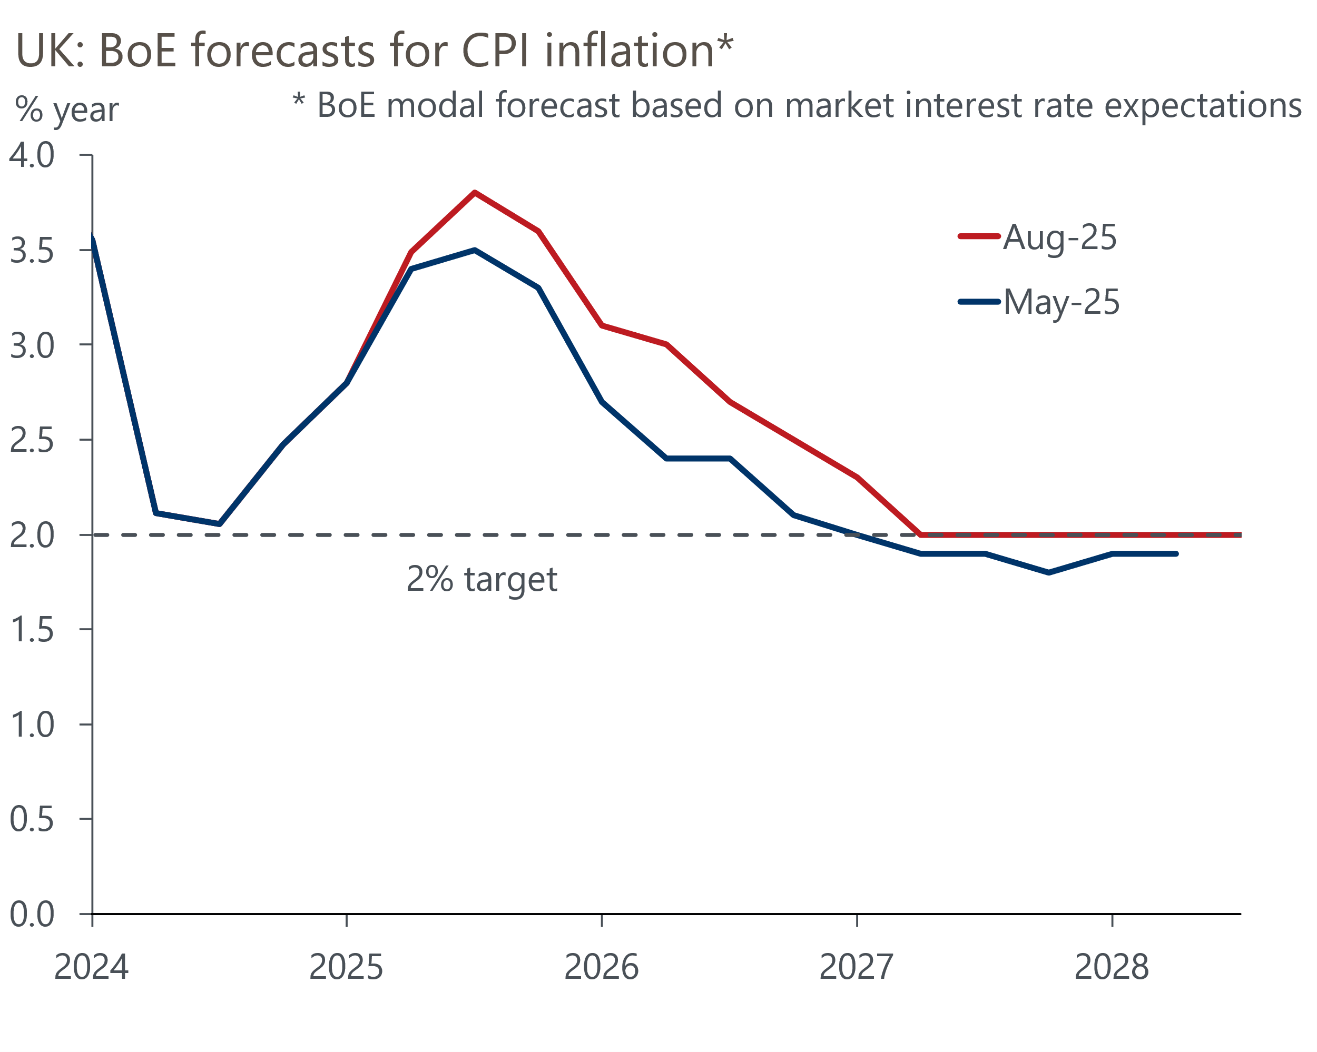
Source: Bank of England Monetary Policy Report

Third, the minutes suggested that most committee members are relatively unfazed by signs that the labour market is continuing to loosen. While hiring conditions have continued to cool, recent data revisions appear to have eased concerns about the fragility of the labour market. Furthermore, the strength of the link between wage growth and domestic prices was also a source of debate for some members.
Still, the MPC's messaging wasn't entirely hawkish. The committee's new forecast showed inflation falling back in line with the BoE's 2% target in two years and remaining there. This implicitly endorsed market pricing in the lead up to the August meeting, which suggested a further reduction in Bank Rate of just over 50bps over the next year. Moreover, the MPC retained its key guidance that "a gradual and careful approach to the further withdrawal of monetary policy restraint remained appropriate."
The MPC has lowered Bank Rate at a quarterly tempo since its rate-cutting cycle began last summer, so the September meeting has always looked a likely 'hold' meeting. On balance, we're sticking with our call that the MPC will cut by 25bps in November. In part, this reflects our view that while inflation is likely to come in broadly in line with the committee's forecast, we think that growth will disappoint in the near term. Indeed, this week's S&P Global survey suggested that activity growth remained sluggish in July, with weaker services sector performance dragging the composite PMI down to 51.5, from 52.0 in June (Chart 2). We expect quarter-on-quarter GDP growth to undershoot the MPC's forecast for a 0.3% pickup in Q3.
Chart 2: July's composite PMI signalled that activity had little upward momentum at the start of Q3
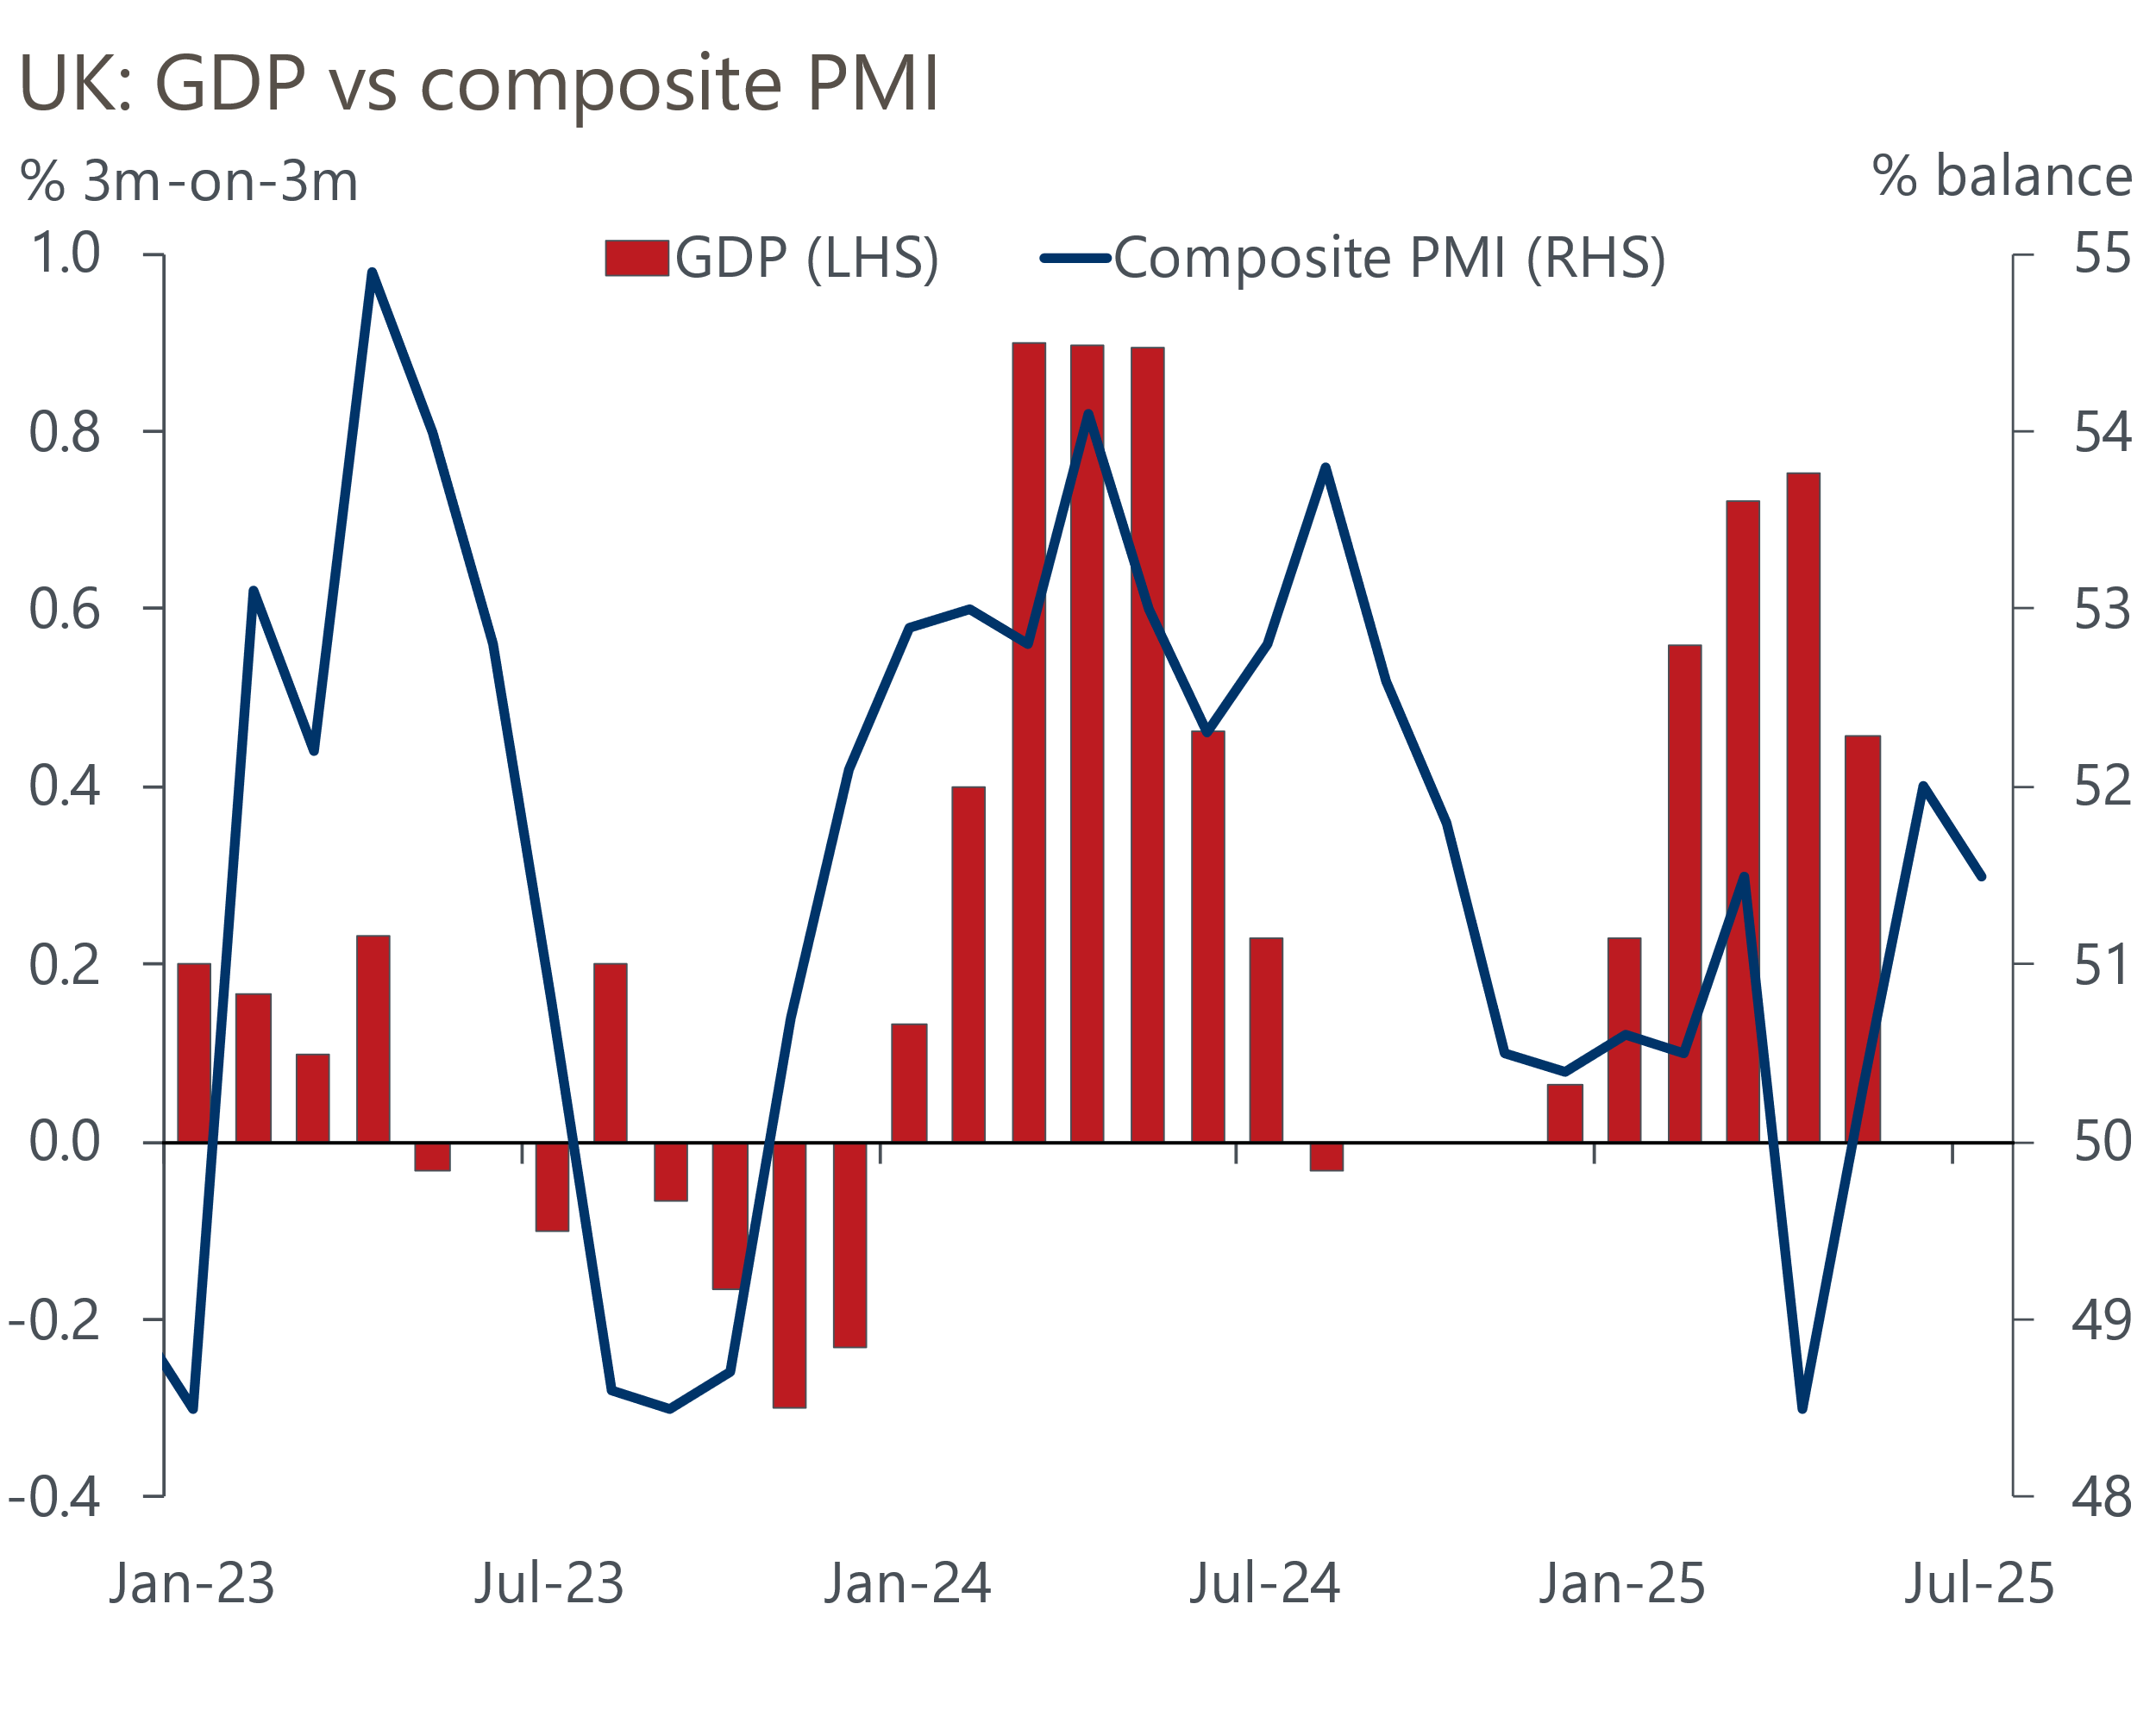
Sources: ONS, S&P Global
Furthermore, if the autumn Budget takes place before the November meeting, the MPC will likely have to factor in further fiscal tightening into its decision-making. So we expect a narrow majority for a 25bps cut in November. But our call is made with much less confidence than before, and should inflation continue to surprise to the upside, this could tip the balance towards a hold.
One reason why it's hard to have much conviction is the MPC's inconsistent messaging, which has veered from hawkish in May to dovish in June and back to hawkish again in August. But for the time being, there appears to be two distinct camps, with Governor Andrew Bailey now clearly the committee's swing voter, so his comments will be key.
August's Monetary Policy Report also contained the BoE's annual review of its quantitative tightening programme. Though it argued that there was little evidence QT has had a marked impact on market liquidity and gilt yields, the BoE acknowledged that changes in market conditions posed a risk that QT could have a greater impact on market functioning in the future. We expect the MPC will vote to lower next year's QT target to £75bn-£80bn, from the current pace of £100bn per year. We also think the BoE will look to focus active gilt sales on short- and medium-dated gilts rather than longs.

The week ahead
The first of the week's two major economic releases is the labour market data for April-June. Pay growth has eased in recent months, reflecting both base effects and fading momentum. We expect headline (three-month average of the annual rate) total pay growth to have fallen to 4.7% in June, due to March's high single-month estimate falling out of the three-month average. But we think regular pay growth is likely to have remained at 4.9% for the three months to June.
Results from the Labour Force Survey remain very volatile. Last month's release saw a spike in the single-month unemployment rate drive up the three-month average that the ONS reports as its headline rate. We expect the three-month average to hold steady at that higher level of 4.7% in April to June.
Next week will also see the release of GDP data for June. Activity fell modestly in May, due to lower readings in the consumer-facing services, manufacturing, and construction sectors, but we expect these sectors to have rebounded in June. In part, this reflects the month's strong rebound in retail sales, which augurs well for distribution output. We're also sceptical that the recent run of poor manufacturing sector outturns is likely to have been sustained in June. As a result, we've pencilled in a 0.1% month-on-month rise in GDP for June. Absent historical revisions, this would mean that GDP rose by 0.1% q/q in Q2.
Table 1: Week ahead calendar
Date | Events | Period | Measure | Unit | Previous | Forecast
Aug 12 | LFS unemployment | Apr-Jun | Rate | % | 4.7 | 4.7
Aug 12 | Average earnings (total pay) | Jun | 3m, y/y | % | 5.0 | 4.7
Aug 12 | Average earnings (regular pay) | Jun | 3m, y/y | % | 4.9 | 4.9
Aug 14 | GDP | Jun | m/m | % | -0.1 | 0.1
Aug 14 | GDP | Jun | 3m/3m | % | 0.5 | 0.1
Aug 14 | Index of services | Jun | m/m | % | 0.1 | 0.1
Aug 14 | Index of services | Jun | 3m/3m | % | 0.4 | 0.2
Aug 14 | Manufacturing output | Jun | m/m | % | -0.1 | 0.3
Aug 14 | Manufacturing output | Jun | y/y | % | 0.3 | -1.0
Aug 14 | Industrial production | Jun | m/m | % | -0.9 | 0.2
Aug 14 | Industrial production | Jun | y/y | % | -0.3 | -0.4
Aug 14 | Construction output | Jun | m/m | % | -0.7 | 0.1
Aug 14 | Construction output | Jun | y/y | % | 1.2 | 1.1
Aug 14 | UK trade | Jun | Trade balance | £bn | -5.7 | -4.3
Aug 14 | UK trade | Jun | Visible balance | £bn | -21.7 | -18.5
Source: Oxford Economics

Key forecasts
Table 2: UK forecast overview
(Annual percentage changes unless specified)
 | 2023 | 2024 | 2025 | 2026 | 2027 | 2028
GDP | 0.4 | 1.1 | 1.1 | 0.9 | 1.3 | 1.8
Private consumption | 0.5 | 0.6 | 1.1 | 1.1 | 1.2 | 1.8
Fixed investment | 0.3 | 1.5 | 1.8 | 0.8 | 1.6 | 2.0
Government consumption | 1.6 | 3.0 | 1.5 | 1.7 | 1.6 | 1.7
Exports of goods and services | -0.4 | -1.2 | 1.2 | 0.1 | 1.2 | 1.4
Imports of goods and services | -1.2 | 2.7 | 3.4 | -1.3 | 1.1 | 1.4
Industrial Production | -0.8 | -1.2 | 0.0 | -0.5 | 0.7 | 1.2
Consumer prices | 7.3 | 2.5 | 3.4 | 2.7 | 2.4 | 2.1
Unemployment rate (%) | 4.1 | 4.3 | 4.7 | 5.0 | 4.9 | 4.5
Current a/c balance (% of GDP) | -3.5 | -2.7 | -3.3 | -2.9 | -2.7 | -2.7
Government balance (% of GDP) | 5.2 | 5.1 | 4.3 | 3.6 | 3.0 | 2.7
Central bank policy rate (%, EOP) | 5.25 | 4.75 | 3.75 | 3.00 | 2.50 | 2.50
10yr govt. bond yield (%, EOP) | 3.54 | 4.57 | 4.55 | 4.04 | 3.47 | 3.35
Exchange rate (US$ per £, EOP) | 1.27 | 1.25 | 1.36 | 1.36 | 1.36 | 1.36
Exchange rate (euro per £, EOP) | 1.15 | 1.21 | 1.17 | 1.17 | 1.17 | 1.17
Source: Oxford Economics
Table 3: Quarterly forecasts for the UK
 | 2025 |  |  |  | 2026
 | Q1 | Q2 | Q3 | Q4 | Q1 | Q2 | Q3 | Q4
GDP (% year) | 1.3 | 0.9 | 1.1 | 1.2 | 0.7 | 0.8 | 0.9 | 1.0
CPI inflation (% year) | 2.8 | 3.5 | 3.8 | 3.5 | 3.3 | 2.5 | 2.5 | 2.5
Bank Rate (%, EOP) | 4.50 | 4.25 | 4.00 | 3.75 | 3.50 | 3.25 | 3.25 | 3.00
10yr gilt yield (%, EOP) | 4.70 | 4.48 | 4.60 | 4.55 | 4.48 | 4.35 | 4.20 | 4.04
US$ per £ (EOP) | 1.29 | 1.37 | 1.36 | 1.36 | 1.36 | 1.36 | 1.36 | 1.36
Euro per £ (EOP) | 1.20 | 1.17 | 1.17 | 1.17 | 1.17 | 1.17 | 1.17 | 1.17
Source: Oxford Economics

Latest Country Economic Forecast:
July 17, 2025

Recent publications

Data Insights
July's PMIs suggest growth remains sluggish
Manufacturing PMI pointed to a slightly shallower decline in July
Mortgage activity continued to recover strongly in June
June rebound in retail sales hides a challenging backdrop
The PMIs started Q3 on a softer note

Research Briefings
Tight BoE vote to cut casts doubt on the path for rates
MPC Preview - The case for faster cuts has faded for now
Why interest rate cuts remain a blunt tool
BoE likely to slow QT to avoid adding to gilt market strains
How the sectoral mix of jobs is changing and what it means

Contacts

Oxford Economics' UK team
- Andrew Goodwin - Chief UK Economist - agoodwin@oxfordeconomics.com
- Edward Allenby - UK Economist - eallenby@oxfordeconomics.com

